Assignment 2- Case Study

Stage 3 Lab Activities

SmartCare Domain Modelling
AI OFF -> AI ON -> COMPARE -> VERIFY | 1 hour

A - Requirements Review
Highlight nouns, verbs and business rules in SmartCare v0.2.
Ans:
Key Nouns: Patient, Practitioner, Appointment, Time Slot, Report.
Key Verbs: Register, Schedule, Prevent, Cancel, View, Search, Generate, Validate.
Business Rules Identified:
- A practitioner cannot be booked for overlapping time slots (preventing double-booking).
- Mandatory fields (such as patient name and appointment time) cannot be blank or null.
- Appointments must strictly link a valid patient and a valid practitioner.

B - Candidate Classes
Record candidate concepts, supporting requirements, state and behaviour.
Ans:
Patient:
- Supporting Requirements: FR-01, FR-08
- State: Patient ID, Name, Contact Details
- Behaviour: Register profile, Update details, Retrieve records
Practitioner:
- Supporting Requirements: FR-02, FR-07
- State: Practitioner ID, Name, Specialization
- Behaviour: View assigned schedule
Appointment:
- Supporting Requirements: FR-03, FR-04, FR-06
- State: Appointment ID, Patient, Practitioner, Time Slot, Status (Booked/Cancelled)
- Behaviour: Schedule appointment, Cancel appointment, Validate slot availability

C - CRC Cards
Create CRC cards for Patient, Practitioner and Appointment.
Ans:
Class Name: Patient
- Responsibilities: Maintain patient personal information and contact records.
- Collaborators: Appointment.
Class Name: Practitioner
- Responsibilities: Maintain practitioner profiles and specialization; track assigned schedule.
- Collaborators: Appointment.
Class Name: Appointment
- Responsibilities: Link a specific patient and practitioner to a unique time slot; manage appointment status (Active/Cancelled).
- Collaborators: Patient, Practitioner.

D - UML Model
Draw classes, attributes, operations, associations and multiplicities.
Ans:
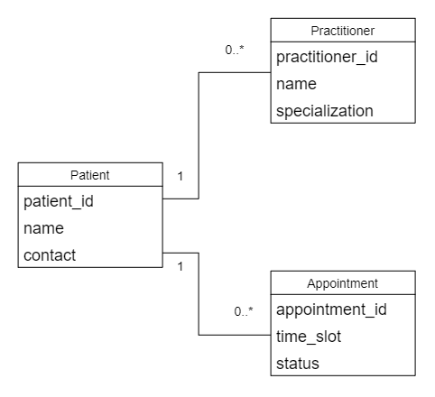
Fig: UML model diagram.

E - AI Design Review
Ask AI to suggest classes and relationships using only confirmed requirements; require supporting requirement IDs.
Ans:
AI Prompt Used: "Act as a software architect. Suggest classes and relationships for SmartCare using only confirmed requirements; require supporting requirement IDs."
AI Review Summary: The AI proposed Patient, Practitioner, and Appointment classes linked to the corresponding functional requirements (FR-01 to FR-04). However, it also overreached by suggesting an external ‘BillingSystem’ and an ‘SMSNotificationService’ class.

F - Compare and Decide
Record at least one accepted, modified and rejected AI suggestion.
Ans:
Accepted: The core classes (Patient, Practitioner, Appointment) and their associations, supported by FR-01 through FR-04.
Modified: Streamlined the attributes of each class to strictly reflect a simple community clinic prototype rather than an enterprise database model.
Rejected: The AI's suggestion for BillingSystem and SMSNotificationService because they lack supporting evidence in the verified client brief and project scope.

G - Python Skeletons
Create simple Patient, Practitioner and Appointment class skeletons.
Ans:
class Patient:
def __init__(self, patient_id, name, contact):
self.patient_id = patient_id
self.name = name
self.contact = contact

class Practitioner:
def __init__(self, practitioner_id, name, specialization):
self.practitioner_id = practitioner_id
self.name = name
self.specialization = specialization

class Appointment:
def __init__(self, appointment_id, patient, practitioner, time_slot):
self.appointment_id = appointment_id
self.patient = patient
self.practitioner = practitioner
self.time_slot = time_slot
self.status = "Booked"

def cancel_appointment(self):
self.status = "Cancelled"

H - Consistency Check
Check model-code consistency; do not implement full behaviour yet.
Ans:
Verified that the class properties and methods in the Python code align precisely with the UML model definitions and CRC card responsibilities.
Confirmed that complex business rules and full database behaviors are omitted at this stage, keeping the code focused solely on structural class skeletons.

Reflection
What modelling decision was hardest? Where did AI over-design? What evidence supported your final choices?
Ans:
The hardest modelling decision was determining the boundary of what data belongs strictly inside core entities versus what attributes can be deferred. The AI over-designed the domain model by introducing enterprise-level components like billing and automated messaging systems. My final choices were firmly supported by evidence from the verified Stage 2 requirements and the original client brief, ensuring the system remains a simple, manageable prototype suitable for a small community clinic.

